|  |
| --- |
| **LAPORAN PRAKTIKUM JARINGAN KOMPUTER**  **4.5.1**  **PACKET TRACER – INTER VLAN ROUTING CHALLENGE** |
|  |
| **Agus Pranata Marpaung**  **13323033**  **DIII TEKNOLOGI KOMPUTER** |
| **INSTITUT TEKNOLOGI DEL**  **FAKULTAS VOKASI** |

**Judul Praktikum**

|  |  |  |
| --- | --- | --- |
| **Minggu/Sesi** | : | XIII/2 |
| **Kode Mata Kuliah** | : | 4332101 |
| **Nama Mata Kuliah** | : | JARINGAN KOMPUTER |
| **Setoran** | : | Jawaban dalam bentuk *softcopy* |
| **Batas Waktu Setoran** | : | *Sesi Praktikum Selanjutnya* |
| **Tujuan** | : | 1. Mahasiswa dapat melakukan konfigurasi VLAN dan Inter-VLAN routing, serta mengaktifkan trunking untuk menghubungkan antar VLAN. |

**Petunjuk**



**Packet Tracer - Inter-VLAN Routing Challenge**

**Addressing Table**

|  |  |  |  |  |
| --- | --- | --- | --- | --- |
| **Device** | **Interface** | **IP Address** | **Subnet Mask** | **Default Gateway** |
| R1  *R1*  *R1*  *R1*  *R1*  *R1* | G0/0 | 172.17.25.2 | 255.255.255.252 | N/A  *N/A*  *N/A*  *N/A*  *N/A*  *N/A* |
| G0/1.10 | 172.17.10.1 | 255.255.255.0 |
| G0/1.20 | 172.17.20.1 | 255.255.255.0 |
| G0/1.30 | 172.17.30.1 | 255.255.255.0 |
| G0/1.88 | 172.17.88.1 | 255.255.255.0 |
| G0/1.99 | 172.17.99.1 | 255.255.255.0 |
| S1 | VLAN 99 | 172.17.99.10 | 255.255.255.0 | 172.17.99.1 |
| PC1 | NIC | 172.17.10.21 | 255.255.255.0 | 172.17.10.1 |
| PC2 | NIC | 172.17.20.22 | 255.255.255.0 | 172.17.20.1 |
| PC3 | NIC | 172.17.30.23 | 255.255.255.0 | 172.17.30.1 |
| Server | NIC | 172.17.50.254 | 255.255.255.0 | 172.17.50.1 |

**VLAN and Port Assignments Table**

|  |  |  |  |
| --- | --- | --- | --- |
| **VLAN** | **Name** |  | **Interface** |
| 10 | Faculty/Staff | F0/11-17 |  |
| 20 | Students | F0/18-24 |  |
| 30 | Guest(Default) | F0/6-10 |  |
| 88 | Native | G0/1 |  |
| 99 | Management | VLAN 99 |  |

**Scenario**

In this activity, you will demonstrate and reinforce your ability to implement inter-VLAN routing, including configuring IP addresses, VLANs, trunking, and subinterfaces.

**Instructions**

Configure the devices to meet the following requirements.

1. Assign IP addressing to R1 and S1 based on the Addressing Table.

**Answer:**

Disini kita mengatur rute R1 untuk menghubungkan beberapa VLAN melalui subinterface di GigabitEthernet0/1 yang masing-masing terhubung dengan VLAN yang berbeda.

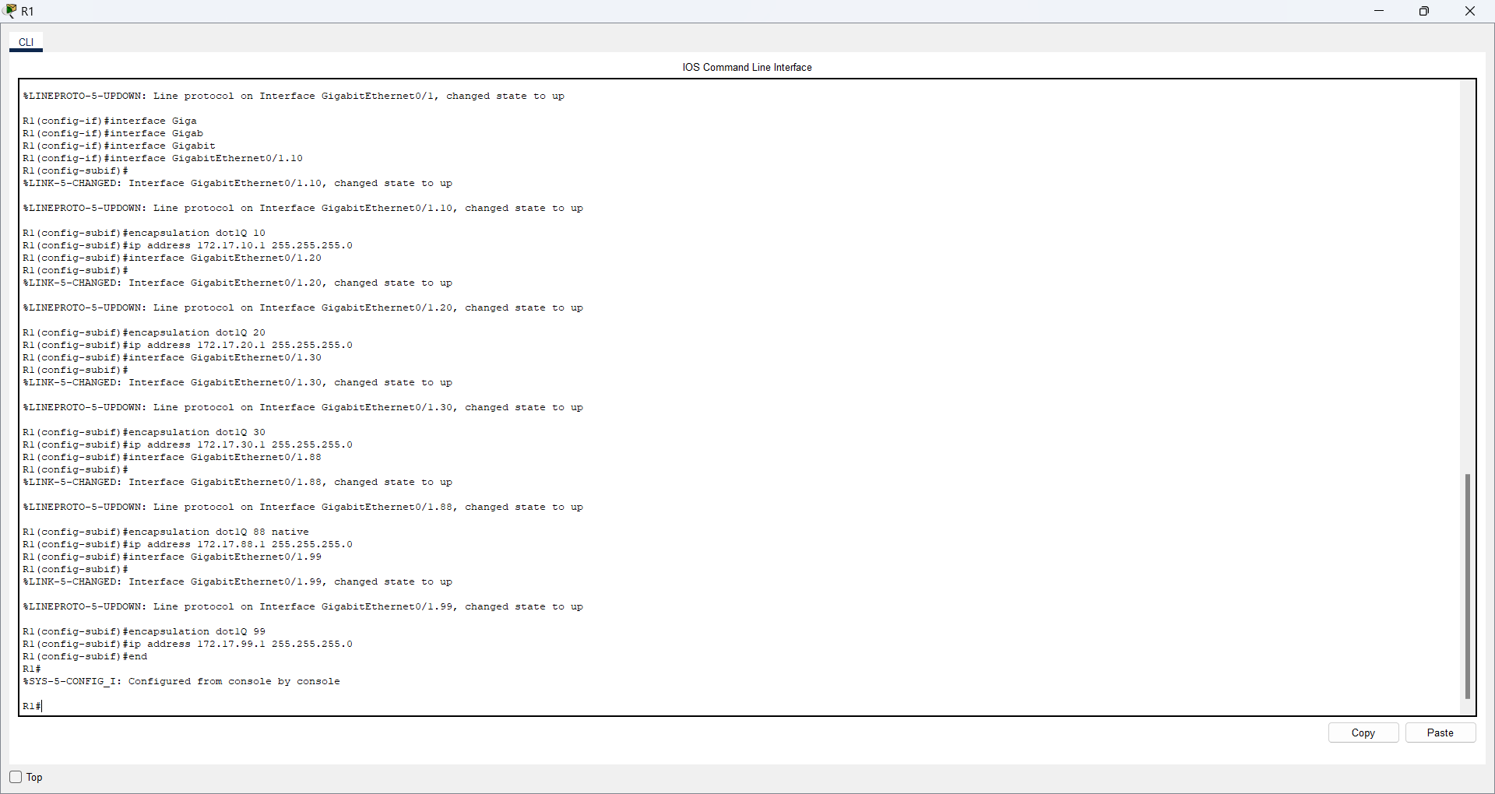

Kemudian pada S1, kita mengkonfigurasi VLAN 99 sebagai salah satu VLAN yang terhubung ke R1.

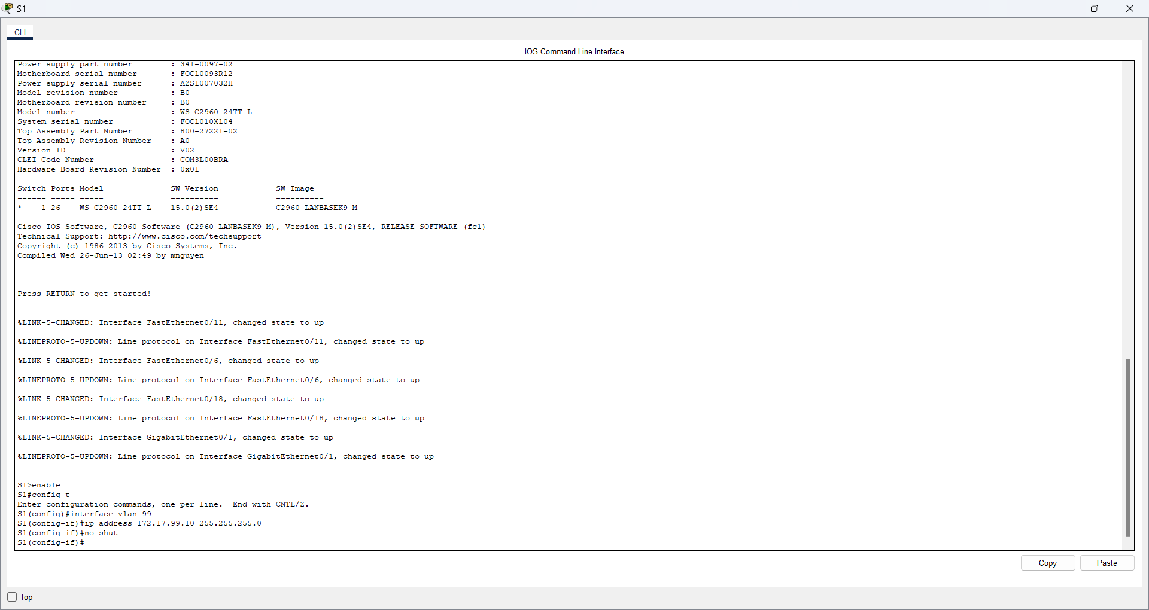

1. Configure the default gateway on S1.

**Answer:**

Perintah dari **ip default-gateway 172.17.99.1** mengkonfigurasi default gateway ke perangkat Switch.



1. Create, name, and assign VLANs on S1 based on the VLAN and Port Assignments Table. Ports should be in access mode. Your VLAN names should match the names in the table exactly.

**Answer:**

Disini saya mengorganisir jaringan dengan mengelompokkan port switch ke dalam VLAN tertentu berdasarkan kebutuhan pengguna, seperti Faculty/Staff, Students, Guest, Native, dan Management. Dan mengatur port tertentu kedalam mode access dan menetapkan VLAN yang sesuai (f0/11-17 untuk VLAN 10, f0/18-24 untuk VLAN 20, dan f0/6-10 untuk VLAN 30).

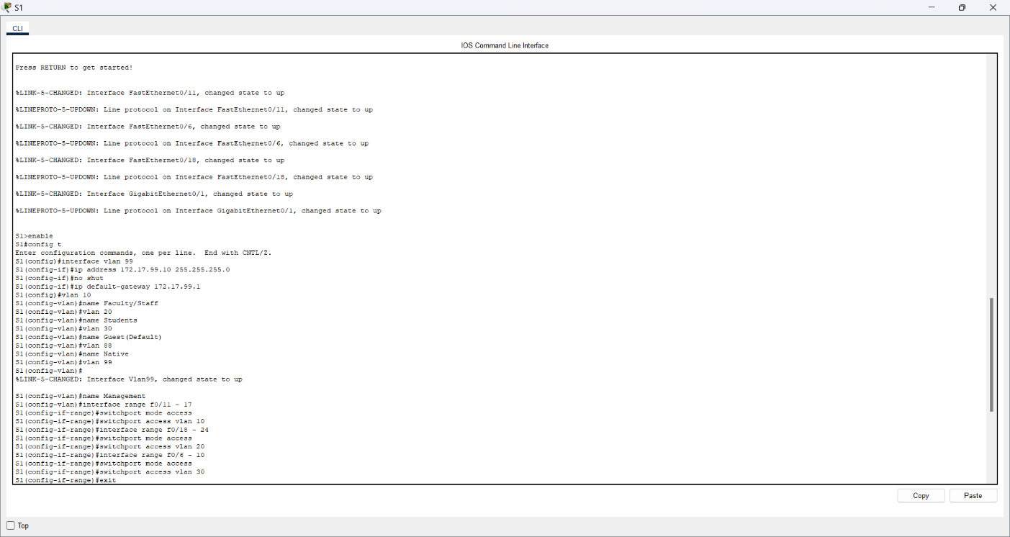

1. Configure G0/1 of S1 as a static trunk and assign the native VLAN.

**Answer:**

Disini saya mengatur interface g0/1 untuk mengangkut lalu lintas berbagai VLAN dan Menetapkan VLAN 88 sebagai native VLAN untuk trunk ini yang bertujuan untuk berkomunikasi antar VLAN yang berbeda melalui trunk interface g0/1.

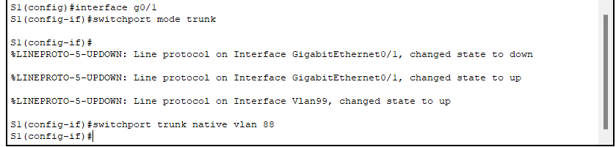

1. **All** ports that are not assigned to a VLAN should be disabled.

**Answer:**

Perintah ini digunakan untuk menonaktifkan interface f0/1 hingga f0/5 serta g0/2 pada switch.

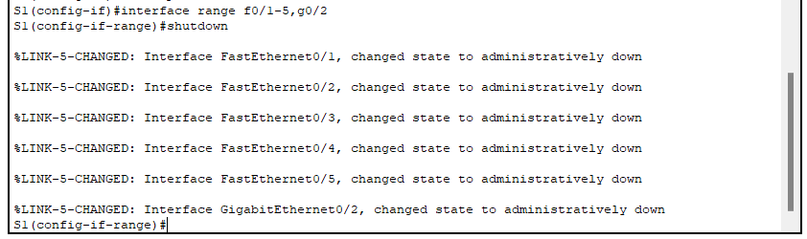

1. Configure inter-VLAN routing on R1 based on the Addressing Table.
2. Verify connectivity. R1, S1, and all PCs should be able to ping each other and the server.

**Answer:**

Disini saya akan melakukan ping ke beberapa IP address pada beberapa PC.

